Comparator Dual Lick Port
Clarizen Project: P-270303
Junchol Park
Jianing Yu

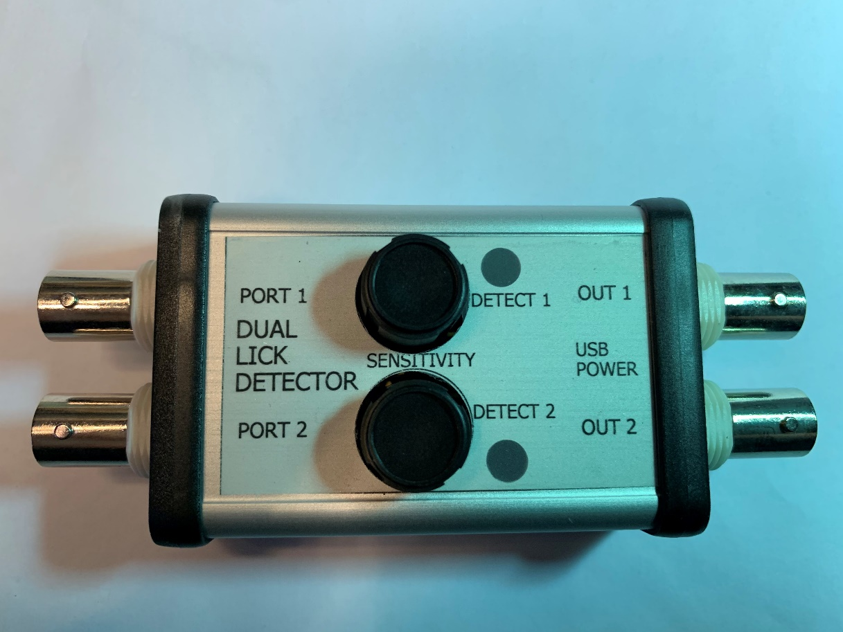

Steve Sawtelle
Engineer, ID&F

Contents
System Overview 2
Hardware Development 2
Assembly, Test, and Calibration 4

System Overview

In “A low-cost solution to measure mouse licking in an electrophysiological setup with a standard analog-to-digital” by Abdallah Hayar, Jeri L. Bryant, John D. Boughter, and Detlef H. Heck in J Neurosci Methods (2006 June 15), a lick detection method is described that measures the potential difference caused by a rodent lick on a metal lick port using an analog-to-digital converter (ADC). The detection was robust and did not create artifacts in electrophysiological recordings. This method was tested at Janelia and found to work well. A circuit was designed to make the design cheaper and self-contained. An adjustable threshold comparator was substituted for the ADC and the circuit was opto-isolated.

Hardware Development

A comparator was chosen to eliminate any high frequency digital noise in the detection circuit and make the design as simple as possible. A dual comparator was used to allow for two lick ports. Sensitivity of response for each port is provided by individual threshold adjustment trimmers. A single Maxim MAX9043 integrated circuit provides both detection channels and the threshold reference. In order to eliminate ground problems between the animal the instrumentation an Analog Devices ADUM5202 isolator is used to isolate the two detector outputs from the downstream instrumentation. It also provides isolated power to the comparator circuit. Connections are provided for LEDs so that lick detection can be checked by eye or put in the video field of view to synchronize licks to video observation. Power (no data) is supplied by a micro-USB cable.

Schematic
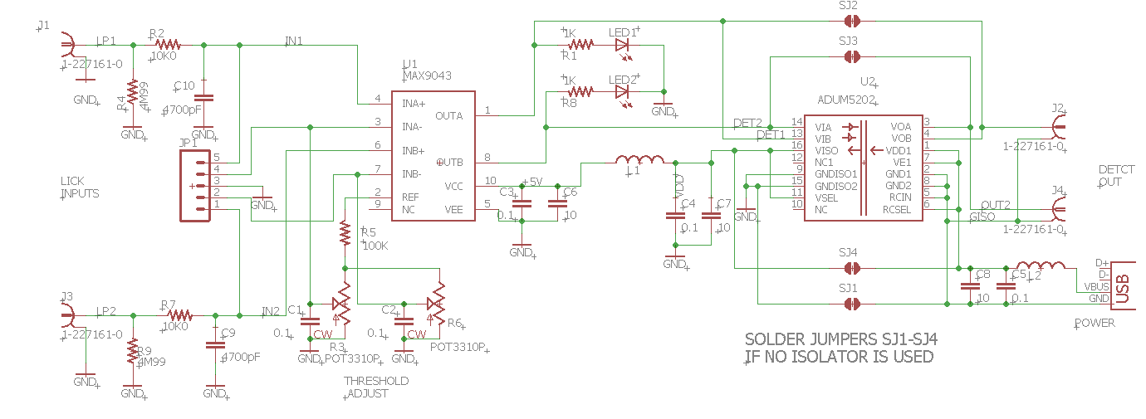

Materials

Assembly, Test, and Calibration

The circuit includes an isolator chip to allow the lick sense ground and output grounds to electrically float relative to each other. If the isolator is not needed, it can be left off, in which case the 4 solder jumpers (SJ1-4) need to be solder bridged.
The board can be ordered from Oshpark via this link:
https://oshpark.com/shared_projects/CPSPhcF2
The connection to the lick port should be done through a short BNC cable with the center (signal) connection attached to the metal lick port tube. The outer (ground) connection should be attached to the animal ground. A good ground is required to minimize 60 Hz interference. It appears that the type of metal used for the ground connection can have a strong effect on the signal level. Generally dissimilar metals for the lick port and cage ground create the best signals (aluminum spout, stainless cage, for example.
The threshold will need to be adjusted to provide reliable output transitions. Adjust the potentiometer for each channel to provide good detections with no false detections.

